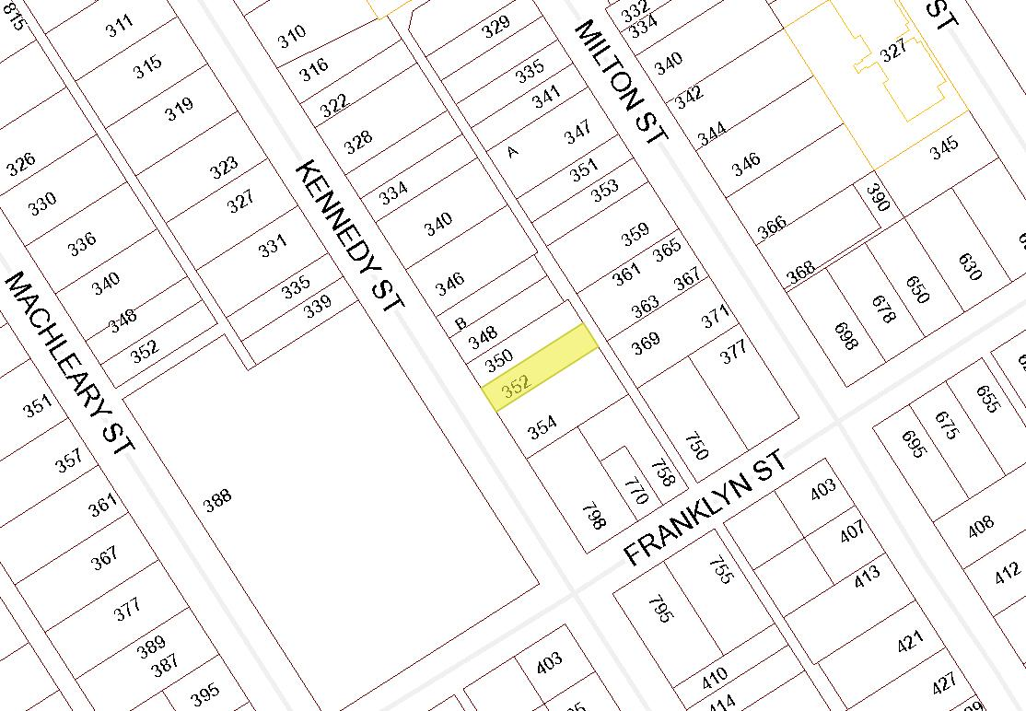

BOARD OF VARIANCE APPLICATION NO. BOV00689

LOCATION MAP

CIVIC: 352 KENNEDY STREET

LEGAL: SECTION C OF LOT 1, BLOCK T, SECTION 1, NANAIMO DISTRICT, PLAN 584

